801.01 Office of Civil Rights & Privacy 2
801.01.01 Statement of Purpose 2
801.01.02 Contact Information 2
801.01.03 Legal Authority 2

801.01 Office of Civil Rights & Privacy
(Rev. 05/01/22)

801.01.01 Statement of Purpose
(Rev. 05/01/22)
The South Carolina Department of Health and Human Services (SCDHHS) is committed to providing services to our applicants and clients in a fair and nondiscriminatory manner. This obligation to comply with federal and state law extends to service contractors and any other agency, institution, or organization, participating with the agency by contract.

The SCDHHS Office of Civil Rights & Privacy has the responsibility to investigate claims of discrimination, to conduct compliance reviews of agency practice, to provide training and guidance, and to take other appropriate steps to ensure that programs and services do not discriminate against any individual.

801.01.02 Contact Information
(Rev. 05/01/22)
To contact the Office of Civil Rights & Privacy call (888) 808-4238, send an email to civilrights@scdhhs.gov, or send a letter to the following address:
ADA, Privacy, and Civil Rights Official
South Carolina Department of Health and Human Services
P.O. Box 8206
Columbia, South Carolina 29202-8206

The Office of Civil Rights & Privacy website contains additional information, including links to the Civil Rights Discrimination Complaint Form and the Health Information Privacy Complaint Form. The website can be found at the following link: https://www.scdhhs.gov/node/1205

801.01.03 Legal Authority
(Rev. 05/01/22)
Any individual applying for or receiving Medicaid benefits from SCDHHS will not be discriminated against in any manner. The following non-discrimination laws apply to SCDHHS:
- Title II of the Americans with Disabilities Act of 1990, guarantees equal opportunity for qualified individuals with disabilities in employment, public accommodations, transportation, public service, state and local government services and communications. This Act requires that interpreters be available for applicants/ beneficiaries, if needed.
  - The SCDHHS Office of Civil Rights & Privacy is responsible for investigating complaints related to the delivery of government services by the agency, including effective communication and special accommodations.
- Title V, Section 504 of the Rehabilitation Act of 1973, as amended, prohibits discrimination based on handicap.
- Title VI of the Civil Rights Act of 1964 prohibits discrimination based on race, color, or national origin.
- The Age Discrimination Act of 1975 prohibits discrimination based on age.

802.01 Civil Rights 5
802.02 Race/Nationality 5
802.02.01 Access to the Application 5
802.02.02 Interpreters 5
802.03 Disability 5
802.03.01 Access to the Application 6
802.03.02 Large Print 6
802.03.03 Braille 6
802.03.04 Relay Services 7
802.03.05 TTY/TDD 7
802.03.06 Barriers 7
802.03.07 Service Animals 7
Appendix A Disability Terminology Chart 9
Appendix B Global Interpreting 10
Appendix C Instructions for Printing Large Print Documents 11

802.01 Civil Rights

802.02 Race/Nationality

802.02.01 Access to the Application
(Rev. 07/01/16)
Each application intake site is required to provide appropriate auxiliary aids and services to individuals with limited English proficiency to give an equal opportunity to apply for and receive services in compliance with non-discrimination mandates under the Civil Rights Act of 1964 and the Americans with Disabilities Act of 1990.

Individuals who have a limited ability to read, write, speak, or understand English are considered to be Limited English Proficient (LEP) individuals. Discrimination against an individual because of the limited ability to use the English language is a form of national origin discrimination, which is prohibited by Title VI of the Civil Rights Act of 1964.

It is important that all individuals have meaningful access to programs that may be offered by SCDHHS. The agency offers language services and access to other auxiliary aids and services at no cost to applicants and beneficiaries. These include but are not limited to:
- Sign language interpreters
- Language Interpreters and translations

802.02.02 Interpreters
(Rev. 05/01/22)
Applicants/beneficiaries who are limited English proficient must be provided with an interpreter to eliminate barriers to applying for services offered under the Medicaid program.

The Eligibility Worker must arrange for auxiliary services such as an interpreter of a person’s native language or sign language. Additional resources may be available through the South Carolina School for the Deaf and Blind.

If the Eligibility Worker determines that a language interpreter is needed, he/she must access Global Interpreting, Inc. (Refer to Appendix B in this chapter.) With supervisory approval, the Eligibility Worker should contact an interpreter and arrange for the service.

802.03 Disability
(Eff. 10/01/15)
SCDHHS may not refuse to allow a person with a disability to participate in a service, program, or activity simply because the person has a disability. Title II of the Americans with Disabilities Act of 1990 (ADA) provides comprehensive civil rights protections for qualified individuals with disabilities. An “individual with a disability” is a person who has a physical or mental impairment that substantially limits a major life activity, has a record of such an impairment, or is regarded as having such an impairment. Examples of physical or mental impairments include, but are not limited to, such contagious and noncontagious diseases and conditions as orthopedic, visual, speech, and hearing impairments, cerebral palsy, epilepsy, muscular dystrophy, multiple sclerosis, cancer, heart disease, diabetes, mental retardation, emotional illness, specific learning disabilities, HIV, tuberculosis, drug addiction, and alcoholism.

802.03.01 Access to the Application
(Rev. 07/01/16)
Each application intake site is required to provide services to the, deaf, blind, or disabled applicant to comply with non-discrimination mandates under the Rehabilitation Act of 1975 and the Americans with Disabilities Act of 1990.

SCDHHS must ensure effective communication with individuals with disabilities. In order to ensure that communications with individuals with hearing, vision, or speech impairments are as effective as communications with others, SCDHHS must provide appropriate auxiliary aids. Auxiliary aids and services must be provided in accessible formats, in a timely manner, and in a way that protects the privacy and independence of the individual with a disability. Auxiliary aids include but are not limited to:
- Sign language interpreters
- Braille materials
- Large print
- Exchange of written notes
- Email
- Text messaging

802.03.02 Large Print
(Eff. 05/01/16)
If an applicant/beneficiary requests an application or document in large print, the Eligibility Worker can either print the document on a BizHub printer (Refer to Appendix C in this chapter.) or send the document to Central Mail via a SharePoint tool and the mailroom will print and mail the document to the applicant/beneficiary.

802.03.03 Braille
(Eff. 07/01/16)
The agency has the Healthy Connections application and various other forms available in Braille. If an applicant makes a request for a Braille application, they can contact the Healthy Connections Member Services Center at 1-888-549-0820. This request will be forwarded to the appropriate local eligibility office to send the requested form(s). The date of application will be the date the individual makes the request for the application from the Member Services Center. If additional forms or documents need to be translated into Braille, please contact the Civil Rights Division using the contact information shown in MPPM 801.02.01.

802.03.04 Relay Services
(Eff. 05/01/16)
If an Eligibility Worker needs to call an applicant/beneficiary who is deaf or hearing impaired, the Eligibility Worker may dial 711 to access Relay Services. Provide the Relay Operator with the applicant/beneficiary’s phone number and the Relay Operator will place the call.

802.03.05 TTY/TDD
(Eff. 05/01/16)
If an applicant/beneficiary who is deaf or hearing impaired wishes to use TTY/TTD to call the agency, the TTY/TDD line is 888-842-3620.

802.03.06 Barriers
(Eff. 10/01/15)
SCDHHS must ensure that individuals with disabilities are not excluded from services, programs, and activities because buildings are inaccessible. Each SCDHHS office, including off-site facilities where eligibility workers work, should have access for individuals with disabilities. Elimination of barriers may be accomplished by
- Relocating a service to an accessible facility,
- Providing a worker to enable an individual with a disability to obtain the service, and
- Providing benefits or services at an individual’s home or at an alternative accessible site.

802.03.07 Service Animals
(Eff. 10/01/15)
A service animal is a dog or miniature horse that is individually trained to work and perform tasks for an individual with a disability. Examples include guiding people who are blind, alerting people who are deaf, pulling a wheelchair, alerting and protecting a person who is having a seizure, reminding a person with mental illness to take prescribed medications, performing specific actions to calm a person with Post Traumatic Stress Disorder (PTSD) during an anxiety attack, or performing other duties.

Under the Americans with Disabilities Act (ADA) SCDHHS offices must permit service animals to accompany people with disabilities in all areas where members of the public are allowed to go. A person with a disability cannot be asked to remove the service animal from the premises unless the animal is out of control and the individual takes no action to control it, or the animal is not housebroken.

When it is not obvious what service an animal provides, only limited inquiries are allowed. Staff may ask:
- Is the animal a service animal required because of a disability?
- What work or task has the animal has been trained to perform?

Staff cannot ask for or require documentation, such as proof that the animal has been certified, trained, or licensed as a service animal. If there is any doubt, always allow for the presence of an animal if it is not unduly disruptive and is not an endangerment.

The fact that the animal is trained to respond to the individual's needs distinguishes it as a service animal. A pet or support animal may be able to recognize that the individual is in distress, but it is what the animal is trained to do in response to this awareness that distinguishes a service animal from an observant pet or support animal. For example, if a service animal senses that a person is about to have a psychiatric episode and it is trained to respond in a specific way, such as by nudging, barking, or removing the individual to a safe location until the episode subsides, then the animal has performed a task or done work on behalf of the individual with the disability, as opposed to merely sensing an event.

802 Appendix A Disability Terminology Chart
(Eff. 10/01/15)
The following chart displays appropriate terminology to use with applicants and beneficiaries who have specific disabilities. Workers should use the terms in the left column, and avoid the terms in the right column.

Use These Terms: | Avoid These Terms:
Accessible parking | Handicapped parking
Children with disabilities | Special needs kids
Individual without an arm/leg/etc. | Amputee
Individual with a physical disability | Handicapped, crippled, or deformed
Individual with a spinal cord injury | Quadriplegic, paraplegic
Individual with Multiple Sclerosis | Person who suffers from Multiple Sclerosis
Individual who uses a wheelchair | Person who is wheelchair-bound, or confined to a wheelchair
Individual who is blind | The blind
Individual who is deaf, or hard or hearing | The deaf, dumb, mute, hearing impaired
Individual with burns | Burn victim, disfigured
Individual who had a stroke | Stroke victim, suffered from a stroke
Individual with a congenital disability | Person with a birth defect, deformed
Individual with a cleft palate | Hare lip
Individual with epilepsy | Epileptic, spastic
Individual living with HIV or AIDS | HIV or AIDS victim
Individual with a learning disability | Retarded, slow learning, stupid
Individual with dyslexia | Dyslexic
Individual with a psychiatric disability | Crazy, lunatic, demented, schizo, psycho
Individual with a speech disability | Speech impairment, speech impediment

802 Appendix B Global Interpreting
(Rev. 08/01/21)
Global Interpreting provides quick and easy access to 200+ languages 24 hours a day, 7 days a week, 365 days a year.

How to reach an interpreter

Over the Phone Interpretation Services:
- Call 833-769-1307 to access Global Interpreting
- You will be greeted by an operator within 5 seconds
- The operator will ask you for the following account information:
  - Department ID: DHHS
  - Access Code: 5 digits
Check with your supervisor or manager if you do not have the access code
If you have a code with less than 5 digits, add zeros to the beginning of your existing code.
Example: Your current code is 1-2-3. Your new code is now 0-0-1-2-3.
  - Language: Spanish, Creole, etc.
- The operator will ask you for the language you require
- The operator will ask you to hold for about 15-30 seconds while they connect to an interpreter that will meet your language requirements
- The operator will connect with the interpreter and will put them on the line with you.
- You will be introduced to the interpreter and be provided with their ID number
- The Global Interpreting operator will stay on the call long enough to ensure the quality of interpretation (right language, all parties communicating, no technical issues, no other assistance required, etc.) after which point the operator will disconnect from the call leaving you with the interpreter.
- The interpreter will remain on the call until you decide they are no longer needed at which point the interpreter will disconnect from the call.

End of session

802 Appendix C Instructions for Printing Large Print Documents
(Eff. 05/01/16)
(Please follow steps 1-7)
- Load 11 x 17 inch paper onto a BizHub Paper tray

- Access the form FM_3400 or forms you need then click Print

- Make sure a BizHub printer is selected then click Properties
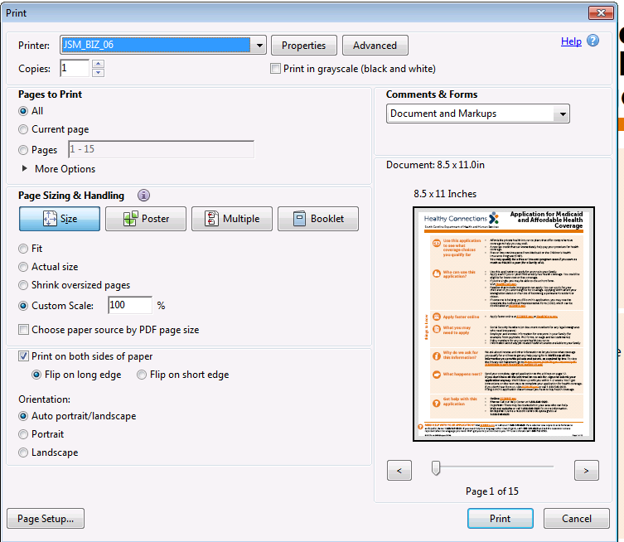

- Select the Finish tab
- Change the Output Tray to the tray you placed the 11 x 17 paper in then click OK
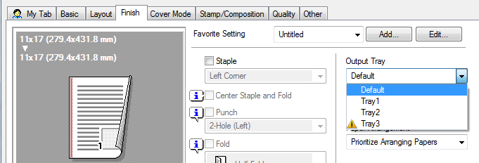

- Now, click Page Setup and change the Paper Size to 11 x 17 then click OK
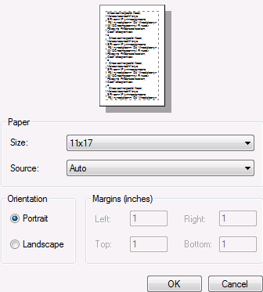

- Lastly, change Custom Scale to 129% then Print
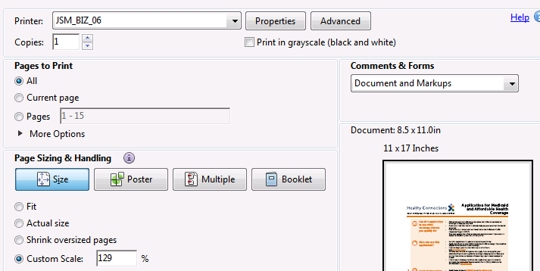

803.01 Complaint Process 15
803.01.01 Evaluating Complaints 15
803.01.02 Investigating Complaints 16
803.01.03 Resolving Investigations 16

803.01 Complaint Process

803.01.01 Evaluating Complaints
(Rev. 05/01/22)
If an applicant or beneficiary believes that he/she experienced discrimination a complaint may be submitted to the agency within 180 days after the alleged act of discrimination. A complaint form is available on the agency’s website. You are not required to use this form. You may instead choose to write a letter or submit a complaint electronically that includes the same information requested on the form. Upon request, alternative means of filing complaints, such as personal interviews or a tape recording, will be made available for persons with disabilities that make submitting a written or electronic complaint impossible.

To contact the Office of Civil Rights & Privacy call (888) 808-4238, send an email to civilrights@scdhhs.gov, or send correspondence to the following address:
ADA, Privacy, and Civil Rights Official
South Carolina Department of Health and Human Services
P.O. Box 8206
Columbia, South Carolina 29202-8206

The Office of Civil Rights & Privacy website contains additional information, including links to the Civil Rights Discrimination Complaint Form and the Health Information Privacy Complaint Form. The website can be found at the following link: https://www.scdhhs.gov/node/1205

After receipt of the complaint, the ADA, Privacy, and Civil Rights Official will contact the applicant/beneficiary within 14 calendar days to discuss the complaint. Within 30 calendar days after the receipt of the complaint, the ADA Coordinator will respond in writing in a format accessible to the individual, such as a letter, large print, Braille, or audio tape. All complaints will be investigated in accordance with state and federal laws and regulations. The ADA, Privacy, and Civil Rights Official’s response will explain the position of the agency and offer options for a substantive resolution of the complaint.

An individual may also contact the United States Department of Health and Human Services directly to file a complaint at:
Barbara Stampul, Acting Regional Manager Voice Phone (800) 368-1019
Office for Civil Rights FAX (404) 562-7881
U.S. Department of Health and Human Services TDD (800) 537-7697
Sam Nunn Atlanta Federal Center, Suite 16T70
61 Forsyth Street, S.W.
Atlanta, GA 30303-8909

803.01.02 Investigating Complaints
(Eff. 10/01/15)
In accordance with SCDHHS policy, the initial complaint investigation will be conducted within fourteen days of its receipt. Whenever possible, complaints will be resolved within 30 days after the initial complaint investigation. If complainants provide complete contact information, they will receive a written response to their complaint and/or a report of the completed investigation.

803.01.03 Resolving Investigations
(Rev. 05/01/22)
If a complaint is alleged or a breach is found and a provider is non-compliant with resolving identified issues, such action is grounds for termination. Providers will be given the opportunity to cure breaches, except in certain circumstances of non-compliance. If they do not cure, SCDHHS will terminate their services.

Electronic records of all compliance reports, compliance data and complaints and subsequent investigations shall be maintained by the Office of Civil Rights & Privacy.

