601.01 Introduction 2
601.02 Definitions and Acronyms 3
601.02.01 Definitions 3
601.02.02 Acronyms 3
601.03 Eligibility Workers and Hospital Workers 4
601.03.01 Eligibility Worker 4
601.03.02 Hospital Worker 4
601.04 Application Process 4
601.05 Eligibility Groups Covered 6
601.05.01 Pregnant Women 6
601.05.02 Family Planning 6
601.05.03 Former Foster Care Children to Age 26 6
601.05.04 Breast and Cervical Cancer Treatment 7
601.05.05 Infants and Children under Age 19 7
601.05.06 Parents and Caretaker Relatives 7
601.06 Length of coverage 7
601.06.01 Coverage Periods 7
601.06.02 Eligibility Period 7
601.07 Retroactive Coverage 8
601.08 Full Determination after PE Period 8
601.08.01 Determination within the PE Period 8
601.08.02 Determination outside of the PE Period 9
601.08.03 Manual Eligibility 9

601.01 Introduction

Effective for healthcare services provided on or after January 1, 2014, hospitals will have the option to perform Presumptive Eligibility (PE) determinations for select Medicaid eligibility group coverage as granted by the Affordable Care Act. Through this program, a qualified hospital may conduct an eligibility determination of a potentially Medicaid-eligible applicant based on his/her self-attestation of income and circumstances. A qualified hospital is one that meets the criteria stated in the SC Medicaid Provider Manual. No verifications are required from the applicant to complete a PE determination. PE may only be applied towards the following SCDHHS categories:

- Pregnant Women,
- Family Planning (FP),
- Former Foster Care (FFC),
- Breast and Cervical Cancer Program (BCCP),
- Infants and Children under Age 19, and
- Parents/Caretaker Relatives (PCR).

Individuals who are determined presumptively eligible will be enrolled in a fee-for-service payment category based on:

- the hospital’s assessment of categorical eligibility,
- household income,
- South Carolina state residency, and
- United States citizenship status, either as a national or satisfactory immigration status as attested by the applicant.

The agency will provide all services covered under the plan during this Presumptive Eligibility Period. An exception to this rule includes pregnant women, who will only receive ambulatory prenatal care.

To participate in the PE program, hospitals must participate in Medicaid, assist individuals in completing PE applications, and must not be disqualified as a qualified hospital. In addition, PE determinations must be performed by a hospital employee, and authority may not be delegated to any non-employee, including employees of affiliated entities. The PE program should be used by hospital workers as a payment option for individuals who attest to being eligible for Medicaid but are unenrolled and unable to complete the full Medicaid application at the time of care; if a patient has any other alternative insurance coverage, the hospital worker should seek to use the alternative coverage rather than the PE coverage. SCDHHS will communicate the program requirements, provide training to participating hospitals, monitor compliance with program requirements, and provide corrective actions as necessary for non-compliance.

601.02 Definitions and Acronyms

601.02.01 Definitions

Application Month | The month in which an applicant applies for Presumptive Eligibility.
Following Month | The month directly following the Application Month.
Full Application Form | This application is the Healthy Connections Application, Form 3400, and should be completed by an applicant for an eligibility determination regarding full Medicaid benefits.
Presumptive Eligibility Application | The Medicaid Presumptive Eligibility Application, Form 3402, is a modified version of the Healthy Connections Application, and should be completed by an applicant for an eligibility determination regarding Presumptive Eligibility.
Presumptive Eligibility Period | The period that begins on the date on which a qualified entity determines that an applicant is presumptively eligible and ends (whichever is earlier):  (1) For an applicant who has filed a Medicaid application and is found eligible for regular Medicaid , the day on which a decision is made on that application; or  (2) For an applicant who has not filed a Medicaid application, the last day of the month following the month in which the determination of presumptive eligibility was made.
Presumptive Income Standard | The highest income eligibility standard established under the plan that is most likely to be used to establish the regular Medicaid eligibility of an applicant.
Qualified Hospital | A type of Qualified Entity that - (1) participates as a provider to make presumptive eligibility determinations consistent with State policies and procedures, (2) assists individuals in completing and submitting the PE application and understanding any documentation requirements, and (3) has not been disqualified by SCDHHS.

601.02.02 Acronyms

ACA | Affordable Care Act
BPA | Benefit Plan Administration
IEG | Intelligent Evidence Gathering
MOA | Memorandum of Agreement
MOU | Memorandum of Understanding
PE | Presumptive Eligibility

601.03 Eligibility Workers and Hospital Workers

601.03.01 Eligibility Worker

The eligibility worker is an SCDHHS employee such as a sponsored Medicaid worker located on site in a hospital. The eligibility worker may assist the hospital in gathering information for the PE application. The eligibility worker may assist the hospital in the calculation of Modified Adjusted Gross Income. The eligibility worker may assist the hospital in operational aspects of the PE program. However, the eligibility worker is prohibited from making the determination of presumptive eligibility on behalf of the hospital.

601.03.02 Hospital Worker

The hospital worker is the hospital employee who will make the presumptive eligibility determination. This person cannot be the employee of an affiliated entity such as a third party financial counselor, navigator, or sponsored Medicaid worker. The hospital worker will assess the information provided by the applicant and make the decision of whether or not to determine the individual presumptively eligible. The hospital worker is responsible for ensuring that all tasks associated with making this determination have been performed such as the completion of the PE application, submitting the determination to SCDHHS, and following up on the completion and submission of the full Medicaid application before the end of the presumptive eligibility period.

601.04 Application Process

The PE process will be initiated when an applicant in an authorized hospital attests to being eligible for Medicaid. The hospital will use their own offline methods to determine whether they will grant the individual presumptive eligibility for Medicaid. If the hospital decides to determine the individual presumptively eligible for Medicaid, they will complete a Form 3402, the Medicaid Presumptive Eligibility Application, which is a modified version of Form 3400, the Healthy Connections Application. This modified version will contain fewer questions than Form 3400. If the hospital determines the individual presumptively eligible, the hospital employee must assist the applicant with completing a full application.

Regardless of whether a full application is completed, Form 3402 will be submitted to a subset of eligibility workers tasked with completing presumptive eligibility determinations. When the application is received by the eligibility worker, they will enter the information into Cúram and use the Manual Eligibility Process to force eligibility for two months. It will be assumed that all PE applicants will be eligible for benefits. The worker processing the application should not attempt to perform any verifications and should always complete a positive eligibility determination. If an authorized representative signs the PE application for applicant, the authorized representative will also need to complete Form 1282.

PE Application Process

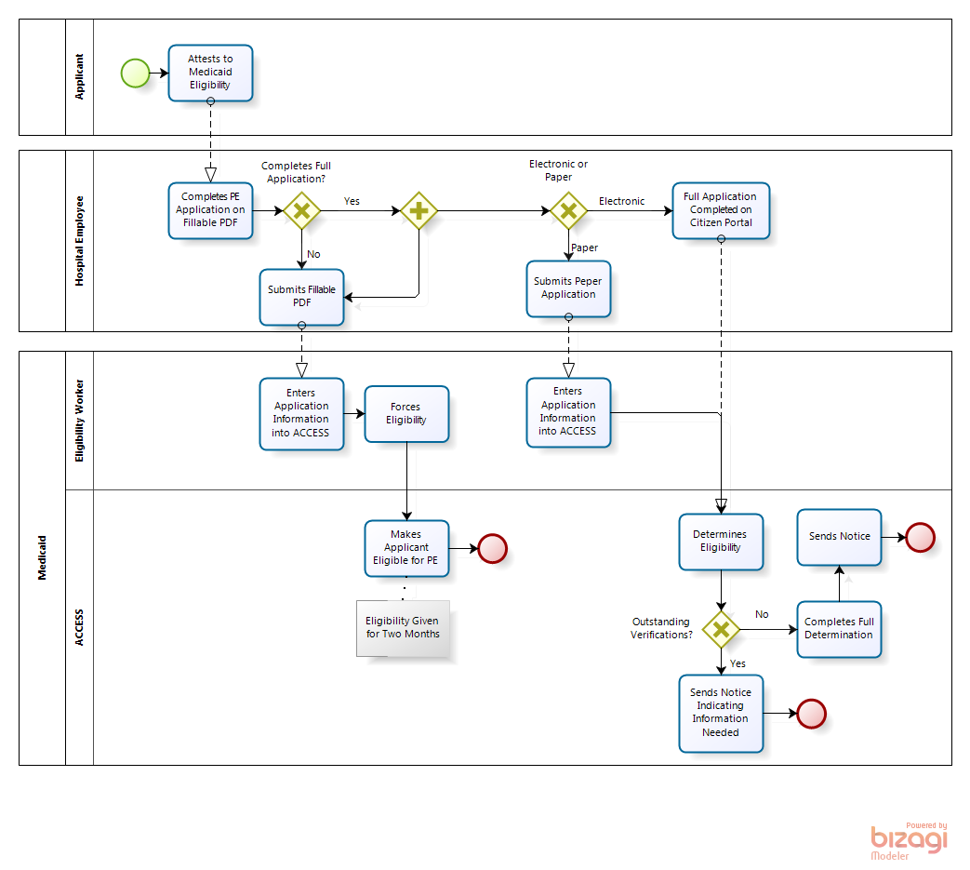

601.05 Eligibility Groups Covered

PE will only be available to the following eligibility groups: Pregnant Women, Family Planning, Former Foster Care Children to Age 26, Breast and Cervical Cancer Program, Infants and Children under Age 19, and Parents and Caretaker Relatives.

Each eligibility group included in the PE program will follow the eligibility criteria set forth under its corresponding Medicaid program. An applicant cannot receive PE if he is already eligible in a full benefit category. Individuals determined eligible for PE will not: (i) be given a protected period of eligibility, (ii) be enrolled in managed care, (iii) receive special FMAP rates, or (iv) be made eligible for Emergency Services. Individuals determined ineligible for PE will not be given a right to an appeal or a fair hearing.

If an applicant is Medicaid-eligible after a full eligibility determination is completed, and qualifies for a protected period, the applicant’s protected period begins the first day of PE.

601.05.01 Pregnant Women

SC DHHS may provide Medicaid to pregnant women during a PE period following a determination by a qualified entity that the pregnant woman has satisfied the criteria set forth in SC MPPM 203.02.01.

Coverage of services provided to such women is limited to ambulatory prenatal care; therefore, eligibility workers should also consider a pregnant woman applicant’s eligibility for Assumptive Eligibility. For more information on Assumptive Eligibility, see MPPM Chapter 203.

A pregnant woman can only be authorized for one PE period per pregnancy.

601.05.02 Family Planning

SC DHHS may provide Medicaid to applicants during a PE period following a determination by a qualified entity that the applicant has satisfied the criteria set forth in SC MPPM 203.02.05.

601.05.03 Former Foster Care Children to Age 26

SC DHHS may provide Medicaid to former foster children during a PE period following a determination by a qualified entity that the former foster child has satisfied the criteria set forth in SC MPPM 203.02.07.

601.05.04 Breast and Cervical Cancer Treatment

SC DHHS may provide Medicaid to individuals with breast or cervical cancer during a PE period following a determination by a qualified entity that the individual has satisfied the criteria set forth in SC MPPM Chapter 501.

601.05.05 Infants and Children under Age 19

SC DHHS may provide Medicaid to individuals under age 19 during a PE period following a determination by a qualified entity that the individual has satisfied the criteria set forth in SC MPPM 203.02.02. (Individuals aged 19 or older and under age 65).

601.05.06 Parents and Caretaker Relatives

SC DHHS may provide Medicaid to a parent or caretaker-relative during a PE period following a determination by a qualified entity that that individual has satisfied the criteria set forth in SC MPPM 203.02.04.

601.06 Length of coverage

601.06.01 Coverage Periods

The PE coverage period will extend from the beginning of the Application Month (the month PE application is submitted) to the earlier of:

- the date an applicant is found eligible for regular Medicaid, if a Medicaid application is filed by the last day of the Following Month (the month after the Application Month); or
- the last day of the Following Month, if no Medicaid application is filed by that date.

Example 1: Applicant applies and is approved for PE on January 2nd. The PE coverage period will be from January 1st to February 28th.
Example 2: Applicant applies and is approved for PE on January 28th. The PE coverage period will be from January 1st to February 28th.
Example 3: Applicant applies and is approved for PE on January 28th and for full Medicaid eligibility on February 4th. The full Medicaid eligibility application is approved February 5th. The PE coverage period will be from January 1st to February 1st.

601.06.02 Eligibility Period

Presumptive Eligibility Periods are limited to no more than one period within two calendar years. The Presumptive Eligibility Period begins on the date the PE determination is made.
A pregnant woman is limited to one PE period per pregnancy.

601.07 Retroactive Coverage

Retroactive coverage cannot be given for a PE determination. However, when a full determination is completed for a PE case, retroactive coverage can be given for up to three months from the date of the full application. See MPPM 601.08 for more information about retroactive coverage following a full determination.

601.08 Full Determination after PE Period
(Rev. 02/01/2015)
When a full determination is completed for a PE case, retroactive coverage can be given for up to three months from the date of the full application. To apply for full benefits, an applicant must complete FM 3400, Healthy Connections Application. The review date will be based on the date the full application is received, not the date of the presumptive eligibility application. Refer to MPPM Section 100 on more information about the full application process.

For example, if an applicant completes a PE application on January 15, 2014, and completes the full application on February 3, 2014, retroactive coverage can be given for up to three months prior to the full application date. In this case, the applicant can receive retroactive coverage for January, December, and November.

When a full application is created and outstanding verifications are needed, a checklist will be mailed to the applicant. If the verification is not returned within 45 days from the day the full application was submitted, then the application will be denied.

601.08.01 Determination within the PE Period

If a full determination is made and the applicant is eligible for full benefits, the applicant may terminate PE that day. A full application will be linked to a PE application if it is completed within the PE period, preventing any gaps in healthcare coverage.

For example, if the PE period lasts from January 1, 2014 to February 28, 2014 and the applicant submits their application on February 15, 2014, then the two applications will be linked.

601.08.02 Determination outside of the PE Period

If an applicant applies for full coverage after their PE Period ends, their full application and PE application will not be linked; therefore, the applicant may experience a gap in their healthcare coverage.

For example, if the PE period lasts from January 1, 2014 to February 28, 2014 and the applicant submits their application on March 15, 2014, then the two applications will not be linked.

601.08.03 Manual Eligibility

If an applicant applies for full coverage following a PE Period in January, February, or March of 2014 and requests retroactive coverage, the eligibility worker must manually insert their retroactive coverage into the ACCESS system. This process is referred to as “Manual Eligibility.”

Manual Eligibility

Workbook: |  |  | ACCESS:
Oct. 2013 | Nov. 2013 | Dec. 2013 | Jan. 2014 | Feb. 2014 | Mar. 2014
Manual Eligibility | Manual Eligibility | Manual Eligibility | Application Submitted/ Coverage Received
No Coverage | Manual Eligibility | Manual Eligibility | Retroactive Eligibility | Application Submitted/ Coverage Received
No Coverage | No Coverage | Manual Eligibility | Retroactive Eligibility | Retroactive Eligibility | Application Submitted/ Coverage Received

